**PRACTICAL: 1**

**AIM: Install Bootstrap framework and understand various tags, attributes of HTML and other necessary files to make responsive web page.**

**What is Bootstrap?**

∙ Bootstrap is a free front-end framework for faster and easier web development

∙ Bootstrap includes HTML and CSS based design templates for typography, forms, buttons, tables, navigation, modals, image carousels and many other, as well as optional JavaScript plugins ∙ Bootstrap also gives you the ability to easily create responsive designs

**Bootstrap Versions**

Bootstrap 3, which was released in 2013. Bootstrap 4 (released 2018) and Bootstrap 5 (released 2021). **Where to Get Bootstrap?**

There are two ways to start using Bootstrap on your own web site.

You can:

Download Bootstrap from getbootstrap.com

Include Bootstrap from a CDN

**Bootstrap CDN**

If you don't want to download and host Bootstrap yourself, you can include it from a CDN (Content Delivery Network).

MaxCDN provides CDN support for Bootstrap's CSS and JavaScript. You must also include jQuery: **MaxCDN:**

<!-- Latest compiled and minified CSS -->

<link rel="stylesheet" href="https://maxcdn.bootstrapcdn.com/bootstrap/3.4.1/css/b ootstrap.min.css">

<!-- jQuery library -->

<script src="https://ajax.googleapis.com/ajax/libs/jquery/3.6.0/jquery.min.js"></s cript>

<!-- Latest compiled JavaScript -->

<script src="https://maxcdn.bootstrapcdn.com/bootstrap/3.4.1/js/bootstrap.min.js"> </script>

**Create First Web Page With Bootstrap**

**1. Add the HTML5 doctype**

Bootstrap uses HTML elements and CSS properties that require the HTML5 doctype.

Always include the HTML5 doctype at the beginning of the page, along with the lang attribute and the correct character set:

**<!DOCTYPE html>**

**<html lang="en">**

**<head>**

**<meta charset="utf-8">**

**</head>**

**</html>**

**2. Bootstrap 3 is mobile-first**

Bootstrap 3 is designed to be responsive to mobile devices. Mobile-first styles are part of the core framework.

To ensure proper rendering and touch zooming, add the following <meta> tag inside the <head> element: **<meta name="viewport" content="width=device-width, initial-scale=1">**

The width=device-width part sets the width of the page to follow the screen-width of the device (which will vary depending on the device).

The initial-scale=1 part sets the initial zoom level when the page is first loaded by the browser. **3. Containers**

Bootstrap also requires a containing element to wrap site contents.

There are two container classes to choose from:

1. The .container class provides a responsive fixed width container

2. The .container-fluid class provides a full width container, spanning the entire width of the viewport

**Example Bootstrap Pages**

<!DOCTYPE html>

<html lang="en">

<head>

<title>Bootstrap Example</title>

<meta charset="utf-8">

<meta name="viewport" content="width=device-width, initial-scale=1">

<link rel="stylesheet" href="https://maxcdn.bootstrapcdn.com/bootstrap/3.4.1/css/bootstrap.min.css ">

<script src="https://ajax.googleapis.com/ajax/libs/jquery/3.6.0/jquery.min.js"></script> <script src="https://maxcdn.bootstrapcdn.com/bootstrap/3.4.1/js/bootstrap.min.js"></script> </head>

<body>

<div class="container">

<h1>My First Bootstrap Page</h1>

<p>This is some text.</p>

</div>

</body>

</html>

**OUTPUT**:

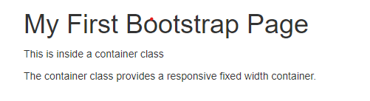

**PRACTICAL: 2**

**AIM: Design web page that shows department name, college name at center of web page by using bootstrap framework and without using bootstrap framework**

<!DOCTYPE html>

<html lang="en">

<head>

<title>Bootstrap Example</title>

<meta charset="utf-8">

<meta name="viewport" content="width=device-width, initial-scale=1"> <linkrel="stylesheet"href="https://maxcdn.bootstrapcdn.com/bootstrap/3.4.1/css/bootstrap.min.css">

<script src="https://ajax.googleapis.com/ajax/libs/jquery/3.6.0/jquery.min.js"></script> <script src="https://maxcdn.bootstrapcdn.com/bootstrap/3.4.1/js/bootstrap.min.js"></script> </head>

<body>

<div class="container">

<center>

<h1>College Name : APOLLO INSTITUTE OF ENGINEERING (DIPLOMA ENGINEERING)</h1>

<h2>Department Name : Computer Engineering </h2>

</center>

</div>

</body> </html>

**OUTPUT:**

**Without using bootstrap**

<!DOCTYPE html>

<html lang="en">

<head>

<title>Example</title>

</head>

<body>

<div>

<h1>College Name : APOLLO INSTITUTE OF ENGINEERING (DIPLOMA ENGINEERING)</h1>

<h2>Department Name : Computer Engineering </h2>

</div>

</body>

</html>

**OUTPUT**:



**PRACTICAL: 3**

**AIM: Display student information content on responsive web page by using container and container-fluid classes.**

Using Container

<!-- Bootstrap container class -->

<!DOCTYPE html>

<html>

<head>

<title>Bootstrap Container Example</title>

<!-- Add Bootstrap Links -->

<link rel="stylesheet" href=

"https://maxcdn.bootstrapcdn.com/bootstrap/3.3.7/css/bootstrap.min.css">

<script src=

"https://ajax.googleapis.com/ajax/libs/jquery/3.3.1/jquery.min.js">

</script>

<script src=

"https://maxcdn.bootstrapcdn.com/bootstrap/3.3.7/js/bootstrap.min.js">

</script>

<style>

body{

font-family: Calibri, Helvetica, sans-serif;

background-color: pink;

}

.container {

padding: 50px;

background-color: lightblue;

}

input[type=text], input[type=password], textarea {

width: 100%;

padding: 15px;

margin: 5px 0 22px 0;

display: inline-block;

border: none;

background: #f1f1f1;

}

input[type=text]:focus, input[type=password]:focus { background-color: orange;

outline: none;

}

div {

padding: 10px 0;

}

hr {

border: 1px solid #f1f1f1;

margin-bottom: 25px;

}

.registerbtn {

background-color: #4CAF50;

color: white;

padding: 16px 20px;

margin: 8px 0;

border: none;

cursor: pointer;

width: 100%;

opacity: 0.9;

}

.registerbtn:hover {

opacity: 1;

}

</style>

</head>

<body>

<!-- Since we are using the class container, the below div will not take complete width of its parent. -->

<div class="container" style="background: green;"> <h1>Student Information </h1>

<form>

<label> Firstname </label>

<input type="text" name="firstname" size="15"/> <br> <br> <label> Middlename: </label>

<input type="text" name="middlename" size="15"/> <br> <br> <label> Lastname: </label>

<input type="text" name="lastname" size="15"/> <br> <br> <label>

Course :

</label>

<select>

<option value="Course">Course</option>

<option value="BCA">BCA</option>

<option value="BBA">BBA</option>

<option value="B.Tech">B.Tech</option>

<option value="MBA">MBA</option>

<option value="MCA">MCA</option>

<option value="M.Tech">M.Tech</option>

</select>

<br>

<br>

<label>

Gender :

</label><br>

<input type="radio" name="male"/> Male <br>

<input type="radio" name="female"/> Female <br> <input type="radio" name="other"/> Other

<br>

<br>

<label>

Phone :

</label>

<input type="text" name="country code" value="+91" size="2"/> <input type="text" name="phone" size="10"/> <br> <br> Address

<br>

<textarea cols="80" rows="5" value="address">

</textarea>

<br> <br>

<input type="button" value="Submit"/> <br> <br> </form>

</div>

</body>

</html>

**OUTPUT:**

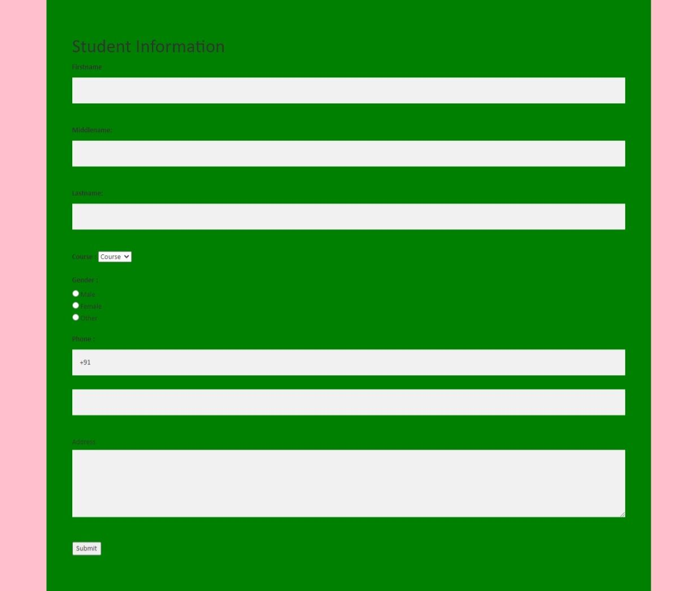

**Using Container-Fluid**

<!-- Bootstrap container-fluid class -->

<!DOCTYPE html>

<html>

<head>

<title>Bootstrap Container Example</title>

<!-- Add Bootstrap Links -->

<link rel="stylesheet" href=

"https://maxcdn.bootstrapcdn.com/bootstrap/3.3.7/css/bootstrap.min.css"> <script src=

"https://ajax.googleapis.com/ajax/libs/jquery/3.3.1/jquery.min.js">

</script>

<script src=

"https://maxcdn.bootstrapcdn.com/bootstrap/3.3.7/js/bootstrap.min.js"> </script>

<style>

body{

font-family: Calibri, Helvetica, sans-serif;

background-color: pink;

}

.container-fluid {

padding: 50px;

background-color: lightblue;

}

input[type=text], input[type=password], textarea {

width: 100%;

padding: 15px;

margin: 5px 0 22px 0;

display: inline-block;

border: none;

background: #f1f1f1;

}

input[type=text]:focus, input[type=password]:focus {

background-color: orange;

outline: none;

}

div {

padding: 10px 0;

}

hr {

border: 1px solid #f1f1f1;

margin-bottom: 25px;

}

.registerbtn {

background-color: #4CAF50;

color: white;

padding: 16px 20px;

margin: 8px 0;

border: none;

cursor: pointer;

width: 100%;

opacity: 0.9;

}

.registerbtn:hover {

opacity: 1;

}

</style>

</head>

<body>

<!-- Since we are using the class container-fluid, the

below div will expand whenever the viewport is resized. --> <div class="container-fluid" style="background: green;"> <h1>Student Information </h1>

<form>

<label> Firstname </label>

<input type="text" name="firstname" size="15"/> <br> <br>

<label> Middlename: </label>

<input type="text" name="middlename" size="15"/> <br> <br>

<label> Lastname: </label>

<input type="text" name="lastname" size="15"/> <br> <br> <label>

Course :

</label>

<select>

<option value="Course">Course</option>

<option value="BCA">BCA</option>

<option value="BBA">BBA</option>

<option value="B.Tech">B.Tech</option>

<option value="MBA">MBA</option>

<option value="MCA">MCA</option>

<option value="M.Tech">M.Tech</option>

</select>

<br>

<br>

<label>

Gender :

</label><br>

<input type="radio" name="male"/> Male <br>

<input type="radio" name="female"/> Female <br> <input type="radio" name="other"/> Other

<br>

<br>

<label>

Phone :

</label>

<input type="text" name="country code" value="+91" size="2"/>

<input type="text" name="phone" size="10"/> <br> <br>

Address

<br>

<textarea cols="80" rows="5" value="address">

</textarea>

<br> <br>

<input type="button" value="Submit"/> <br> <br>

</form>

</div>

</body>

</html>

**OUTPUT:**

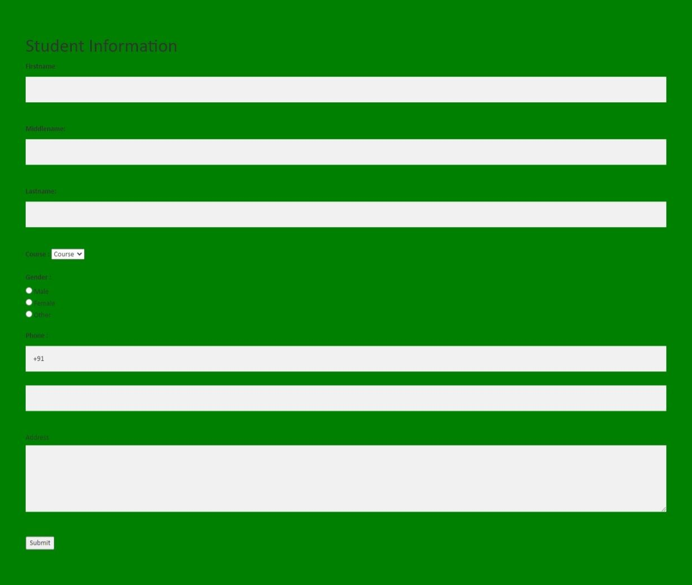

**PRACTICAL: 4**

**AIM: Use offset column, reordering column and Nesting column to create responsive web page for given format.**

**Responsive Columns**

We know that we have four grid classes (xs, sm, md, lg). So, in these Responsive columns, we use one or all four grid for layout, according to the device or viewport size. It’s up to you in how many columns you want to divide Grid individually in your page; on different devices and how many columns group you want on different devices.

**Example:**

In the following example, the layout has been divided into two grid class (sm & md) for different device viewport. We are dividing here columns for small devices as .col-sm-4, .col-sm-4, .col-sm-4 and for large device.col-md-4 .col-md-3, .col-md-5.

<! ---------- Responsive columns ---------->

|  |
| --- |
| <!DOCTYPE html>  <html lang="en">  <head>  <title>Bootstrap Example</title>  <meta charset="utf-8">  <meta name="viewport" content="width=device-width, initial-scale=1">  <link rel="stylesheet" href="https://maxcdn.bootstrapcdn.com/bootstrap/3.4.1/css/bootstrap.min.css ">  <script src="https://ajax.googleapis.com/ajax/libs/jquery/3.6.0/jquery.min.js"></script> <script src="https://maxcdn.bootstrapcdn.com/bootstrap/3.4.1/js/bootstrap.min.js"></script> </head>  <body>  <h2 style="color:blue;">Responsive Columns</h2><br />  <div class="container-fluid">  <div class="row">  <div class="col-sm-4 col-md-3">  <h3 style="background-color:skyblue;text  align:center;">  we use 4 col in small and 3 col in large device  in 12 columns.  </h3>  </div>  <div class="col-sm-4 col-md-5">  <h3 style="background-color:yellow;text-align:center;">  we use 4 col in small and 5 col in large device in 12  columns.  </h3>  </div>  <div class="col-sm-4 col-md-4">  <h3 style="background-color:pink;text-align:center;">  we use 4 col in small and 4 col in large device in 12  columns.  </h3>  </div>  </div>  </div>  </body>  </html> |

**OUTPUT:**

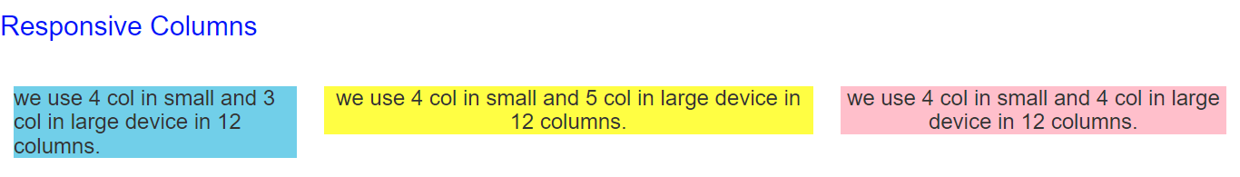

**Nesting Columns**

It is similar to something we have already used, that is; the nested loop and conditional statement in programming languages (In C, C++ & other). To test your content, you have to add a row and col-*-* class within an existing col-*-* class.

**Note:** The nested row should include scales up to 12 columns as the device or viewport. **Example:**

In the following example, layout has been divided into two columns .col-sm-8 and .col-sm-4 both are split into two parts, In which first one is split into .col-sm-4 and .col-sm-8 & second is split into .col-sm 6 and .col-sm-6.

|  |
| --- |
| <!DOCTYPE html>  <html lang="en">  <head>  <title>Bootstrap Example</title>  <meta charset="utf-8">  <meta name="viewport" content="width=device-width, initial-scale=1">  <link rel="stylesheet" href="https://maxcdn.bootstrapcdn.com/bootstrap/3.4.1/css/bootstrap.min.css ">  <script src="https://ajax.googleapis.com/ajax/libs/jquery/3.6.0/jquery.min.js"></script> <script src="https://maxcdn.bootstrapcdn.com/bootstrap/3.4.1/js/bootstrap.min.js"></script> </head>  <body>  <!----------- Nesting Columns --------------->  <h2 style="color:blue;">Nesting Columns</h2><br />  <div class="container-fluid">  <div class="row">  <div class="col-sm-8">  <h3 style="background-color:lightgreen;text  align:center;">  we use 8 columns in 12 columns.  </h3>  <div class="row">  <div class="col-sm-4">  <h5 style="background-color:Aqua;text  align:center;">4 col</h5>  </div>  <div class="col-sm-8">  <h5 style="background-color:Aqua;text  align:center;">8 col</h5> </div>  </div>  </div>  <div class="col-sm-4">  <h3 style="background-color:lightgrey;text  align:center;">  we use 4 columns in 12 columns.  </h3>  <div class="row">  <div class="col-sm-6">  <h5 style="background-color:Aqua;text  align:center;">6 col</h5>  </div>  <div class="col-sm-6">  <h5 style="background-color:Aqua;text  align:center;">6 col</h5>  </div>  </div>  </div>  </div>  </div>  </body>  </html> |

**OUTPUT:**

**Mobile and tablet view for Both Responsive and Nesting columns:**

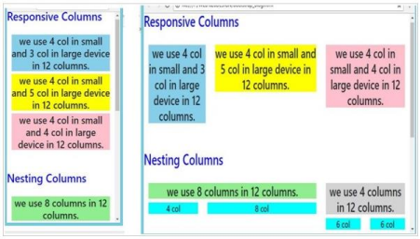**Offset Columns**

You can also use offset grid columns. It provides a specialized layout. It also has four grid classes. For this, we have to use offset -*-*. These classes are used to increase the left margin of columns where columns can move an only right side and we increase left margin to the columns by using offset -*-* and it ranges from 1-11. Margins are more useful for quick layouts where the variable is the width of the offsets.

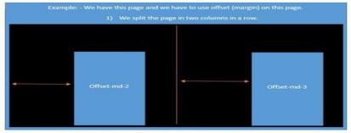

**Example:**

In the following example, specialized layout is used and divided into two columns (col-md-4 col-sm-4 col lg-4) and (col-md-4 col-sm-4 col-lg-4). Here, we use offset in both the splitted columns offset-md 2 & offset-md-1 as you can see in the example. Under this spitted two columns we again use offset in contact; we use offset for margin where offset-md-2 & offset-md-0 moves over columns col-md-4 col-sm 4 col-lg-4 offset-md-2 & col-md-4 col-sm-4 col-lg-4 offset-md-1.

|  |
| --- |
| <!DOCTYPE html>  <html lang="en">  <head>  <title>Bootstrap Example</title>  <meta charset="utf-8">  <meta name="viewport" content="width=device-width, initial-scale=1">  <link rel="stylesheet" href="https://maxcdn.bootstrapcdn.com/bootstrap/3.4.1/css/bootstrap.min.css ">  <script src="https://ajax.googleapis.com/ajax/libs/jquery/3.6.0/jquery.min.js"></script> <script src="https://maxcdn.bootstrapcdn.com/bootstrap/3.4.1/js/bootstrap.min.js"></script> </head>  <body>  <!----------- Offset Columns --------------->  <h2 style="color:blue;">Offset Columns</h2>  <br />  <div class="container-fluid">  <div class="row">  <div class= "col-md-4 col-sm-4 col-lg-4 offset-md-2">  <h1>Contact</h1>  <br>  <div class="row">  <div class="col-sm-8 col-lg-5 offset-md-2">  <form action="" target="_blank">  <p><input type="text" placeholder="Name" class="box" required name="Name"></p>  <p><input type="text"  placeholder="Comments" required name="Comment" class="box"  style=" height:150px;"></p>  <p><button style="color:black; margin-left:35%" class="btn btn info" type="submit"><b>SUBMIT</b></button></p>  </form>  </div>  </div>  <div class= "col-md-4 col-sm-4 col-lg-4 offset-md-1">  <h1>Contact</h1>  <br>  <div class="col-md-5 col-lg-5 offset-md-0">  <form action="" target="_blank">  <p><input type="text" placeholder="Name" class="box" required name="Name"></p>  <p><input type="text"  placeholder="Comments" required name="Comment" class="box"  style=" height:150px;"></p>  <p><button style="color:black; margin-left:35%" class="btn btn info" type="submit"><b>SUBMIT</b></button></p>  </form>  </div>  </div>  </body>  </html> |

**OUTPUT:**

**Mobile and tablet view for Offset columns:**

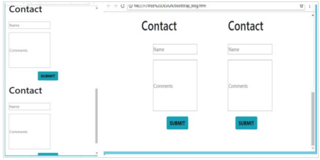

**Practical 5**

**AIM-Create responsive web page of your class time table by using bootstrap grid system.**

<!DOCTYPE html>

<html>

<link rel="stylesheet" href="https://maxcdn.bootstrapcdn.com/bootstrap/3.4.1/css/bootstrap.min.css ">

<script src="https://ajax.googleapis.com/ajax/libs/jquery/3.6.0/jquery.min.js"></script> <script src="https://maxcdn.bootstrapcdn.com/bootstrap/3.4.1/js/bootstrap.min.js"></script>

<body>

<div class="container">

<h1 align=”center”>TIME TABLE</h1>

<table border="5" cellspacing="0" align="center">

<!--<caption>Timetable</caption>-->

<tr>

<td align="center" height="50"

width="100"><br>

<b>Day/Period</b></br>

</td>

<td align="center" height="50"

width="100">

<b>I<br>9:30-10:20</b>

</td>

<td align="center" height="50"

width="100">

<b>II<br>10:20-11:10</b>

</td>

<td align="center" height="50"

width="100">

<b>III<br>11:10-12:00</b>

</td>

<td align="center" height="50"

width="100">

<b>12:00-12:40</b>

</td>

<td align="center" height="50"

width="100">

<b>IV<br>12:40-1:30</b>

</td>

<td align="center" height="50"

width="100">

<b>V<br>1:30-2:20</b>

</td>

<td align="center" height="50"

width="100">

<b>VI<br>2:20-3:10</b>

</td>

<td align="center" height="50"

width="100">

<b>VII<br>3:10-4:00</b>

</td>

</tr>

<tr>

<td align="center" height="50">

<b>Monday</b></td>

<td align="center" height="50">Eng</td>

<td align="center" height="50">Mat</td>

<td align="center" height="50">Che</td>

<td rowspan="6" align="center" height="50">

<h2>L<br>U<br>N<br>C<br>H</h2>

</td>

<td colspan="3" align="center"

height="50">LAB</td>

<td align="center" height="50">Phy</td> </tr>

<tr>

<td align="center" height="50">

<b>Tuesday</b>

</td>

<td colspan="3" align="center"

height="50">LAB

</td>

<td align="center" height="50">Eng</td> <td align="center" height="50">Che</td> <td align="center" height="50">Mat</td> <td align="center" height="50">SPORTS</td>

</tr>

<tr>

<td align="center" height="50">

<b>Wednesday</b>

</td>

<td align="center" height="50">Mat</td> <td align="center" height="50">phy</td> <td align="center" height="50">Eng</td> <td align="center" height="50">Che</td> <td colspan="3" align="center"

height="50">LIBRARY

</td>

</tr>

<tr>

<td align="center" height="50">

<b>Thursday</b>

</td>

<td align="center" height="50">Phy</td> <td align="center" height="50">Eng</td> <td align="center" height="50">Che</td> <td colspan="3" align="center"

height="50">LAB

</td>

<td align="center" height="50">Mat</td> </tr>

<tr>

<td align="center" height="50">

<b>Friday</b>

</td>

<td colspan="3" align="center"

height="50">LAB

</td>

<td align="center" height="50">Mat</td> <td align="center" height="50">Che</td> <td align="center" height="50">Eng</td> <td align="center" height="50">Phy</td> </tr>

<tr>

<td align="center" height="50">

<b>Saturday</b>

</td>

<td align="center" height="50">Eng</td>

<td align="center" height="50">Che</td>

<td align="center" height="50">Mat</td>

<td colspan="3" align="center"

height="50">SEMINAR

</td>

<td align="center" height="50">SPORTS</td>

</tr>

</table>

</div>

</body>

</html>

**Output:**

